ENTER AN ATHLETICS MEETING VIA ROSTER
Although the app for mobile phones is perfectly acceptable, I have found that registering with Roster and looking at schedules/results is rather better on tablets or laptops
Go to https://www.rosterathletics.com/en-GB/
In the search box, add the venue (for example, Yeovil for the Somerset AA championship) and press ‘Enter’
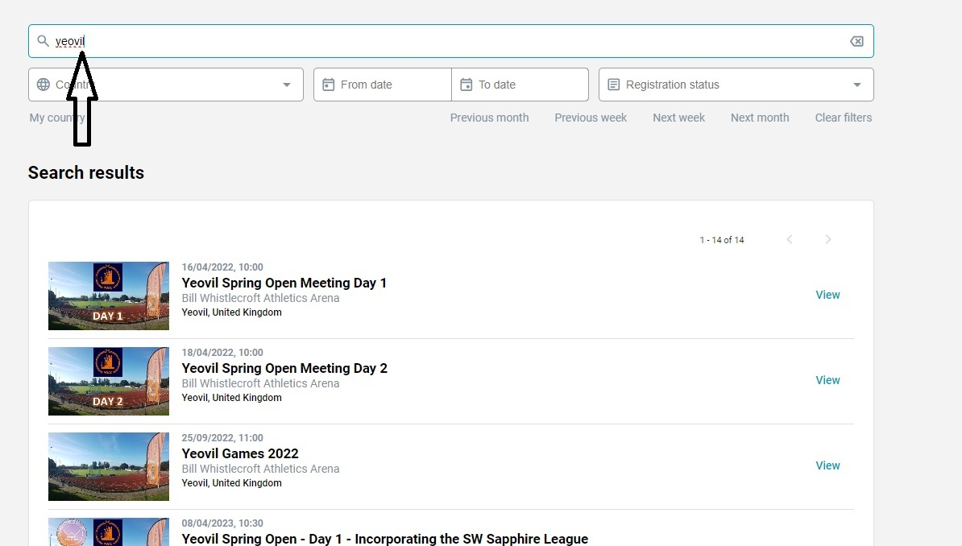
If there are multiple competitions listed for the venue then scroll
towards the bottom of the list
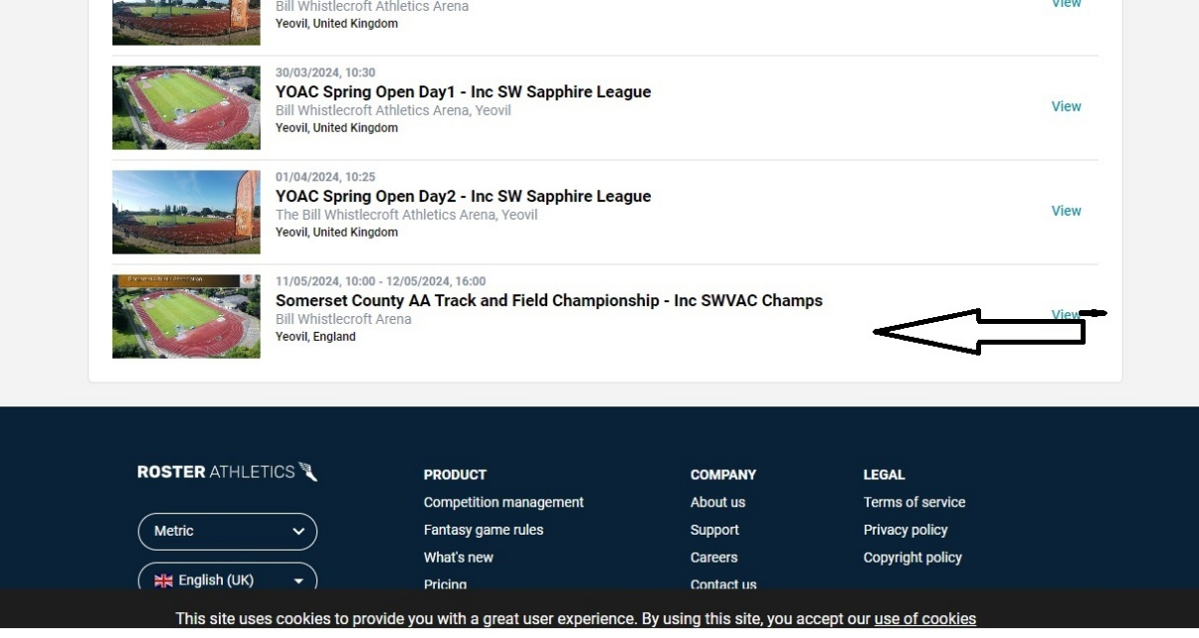
Find the meeting that you want and click on it
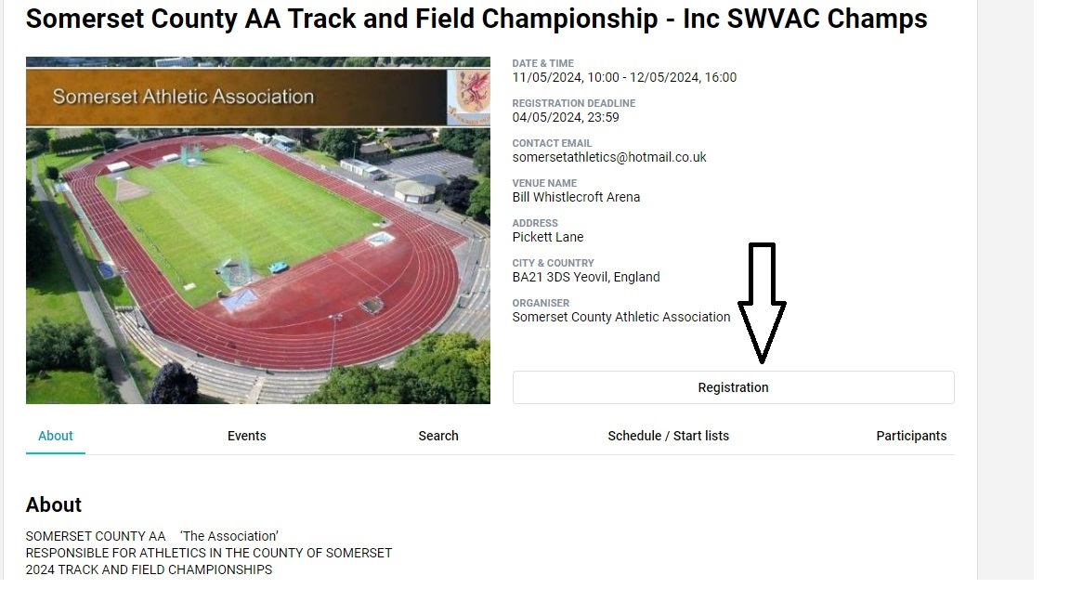
Click on ‘Registration’
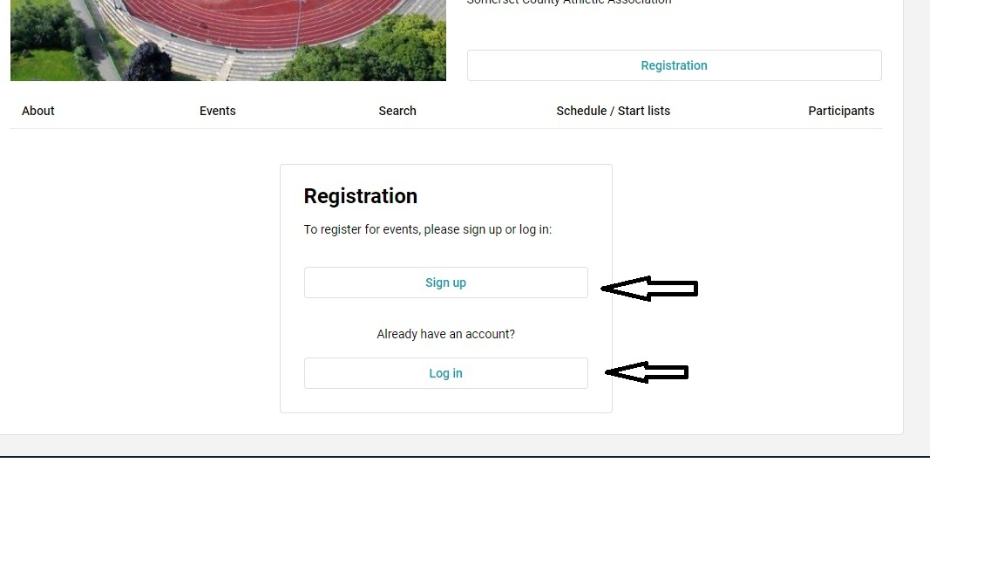
Click ‘Sign up’ if you have not registered with Roster before
when Signing In for the first time I suggest that the athlete avoids using first name abbreviations or nicknames. If the athlete is known to the Power of 10 database then use that same title.
Click ‘Log In’ if you have registered with Roster previously
Then select the event(s) that you want to contest

