COUNTY QUALIFICATION CRITERION
If you were born in the current County of Somerset then you will always be able to claim a qualification to compete for Somerset or compete as a Somerset qualified athlete in our County championships. This County qualification applies if you were born in the County as shown below-
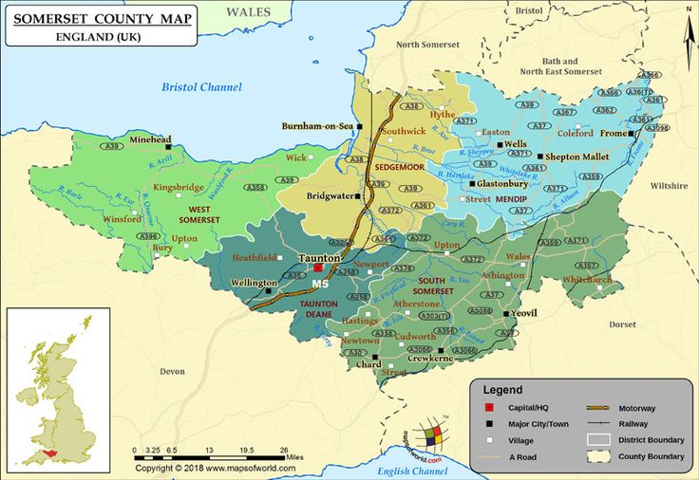
Alternatively, you may prefer to claim a qualification for Somerset through residence in the County shown above and that is completely acceptable (9 months residence required).
Athletes who were born or reside in the Unitary Authorities of North Somerset or Bath and North East Somerset should regard themselves as AVON AA athletes (unless they were born in the current County of Somerset).
See the two maps below for the boundaries of these two unitary authorities-
BANES
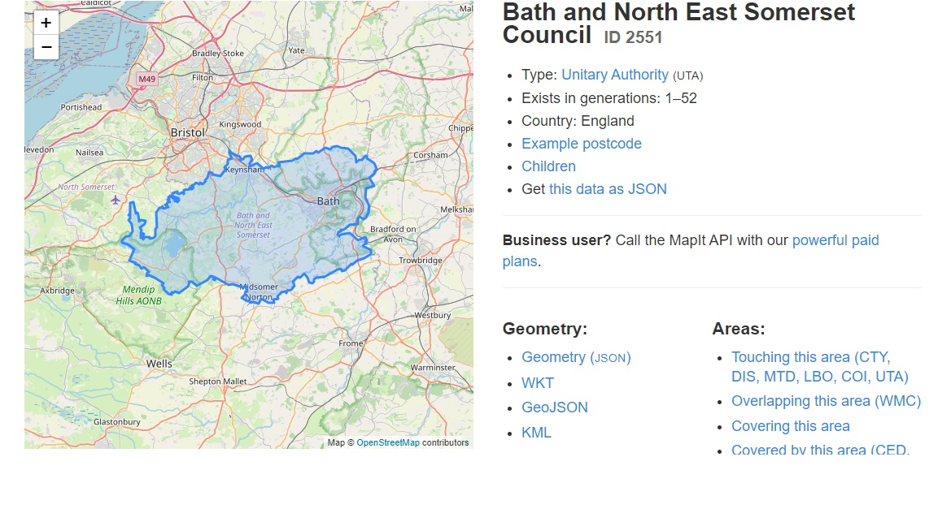
https://mapit.mysociety.org/area/2551.html displays an interactive map of BANES
NORTH SOMERSET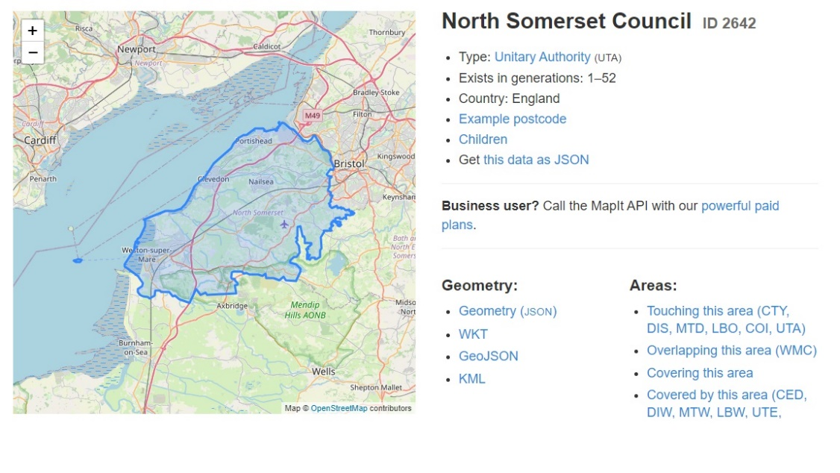
https://mapit.mysociety.org/area/2642.html displays an interactive map of North Somerset

SCHOOLS ASSOCIATIONS
Remember that Schools Athletic Associations have different rules
The school that the athlete attends determines the COUNTY SCHOOL affiliation and does not consider residence or birth

